- Purpose

A Munters dessicant-wheel type dehumidifier has been installed to dry the air feeding the dryers. This procedure is for starting up, checking, and shutting down the dehumidifier.

- Scope

This procedure applies to the Dryer Air Dehumidifier at the Manufacturing Facility.

- Responsibility

Lead Operator or Assistant Operator will be responsible for this procedure.

- Safety Considerations

Observe all Manufacturing safety requirements. Safety glasses and steel toed shoes are required at a minimum.

Safety is a condition of employment. Employees are not authorized to work in an unsafe manner and are prohibited from harming the environment of the facility or the community.

- Materials/Equipment

N/A

- Procedure

- Start Up

    - At the dehumidifier control panel, turn the switch from “Off” to “Manual”.

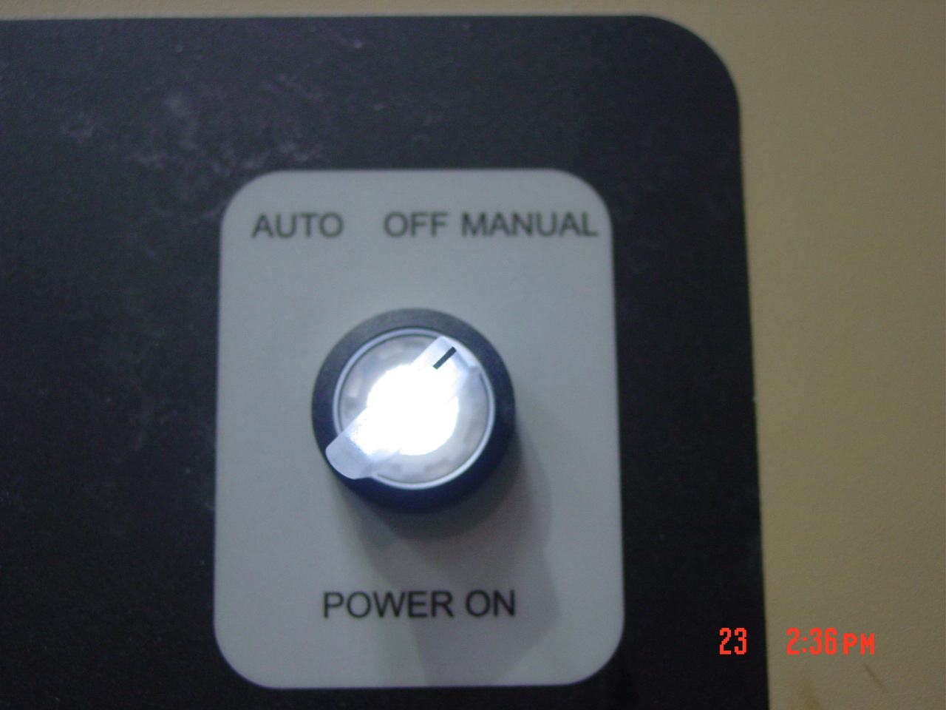

    - With gloves on, open the dehumidifier steam supply valve completely.

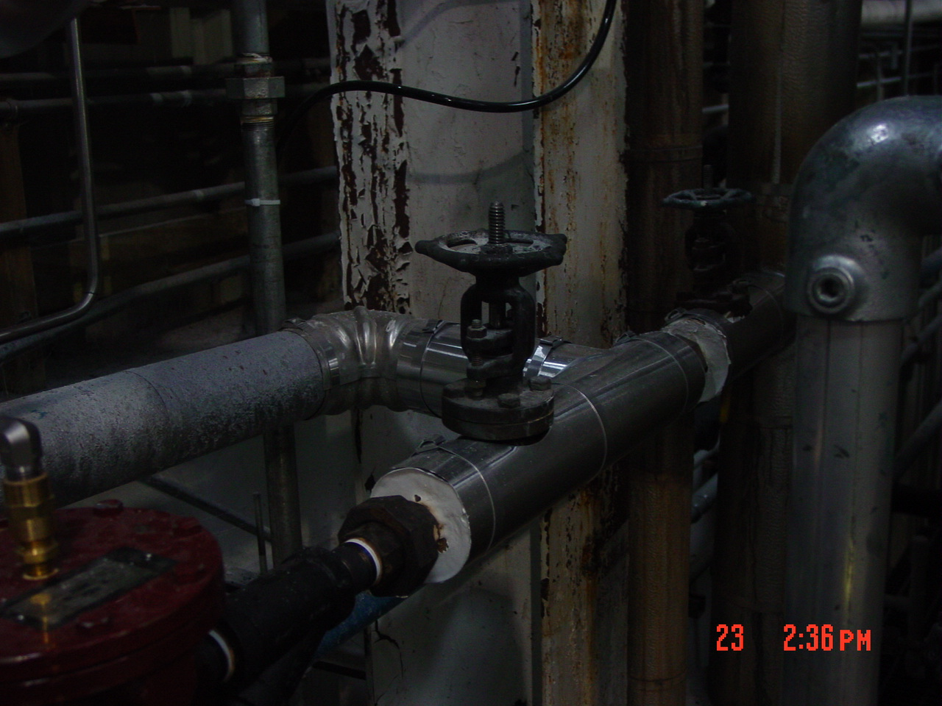

    - Ensure the wall switch for the condensate pump is “On”.

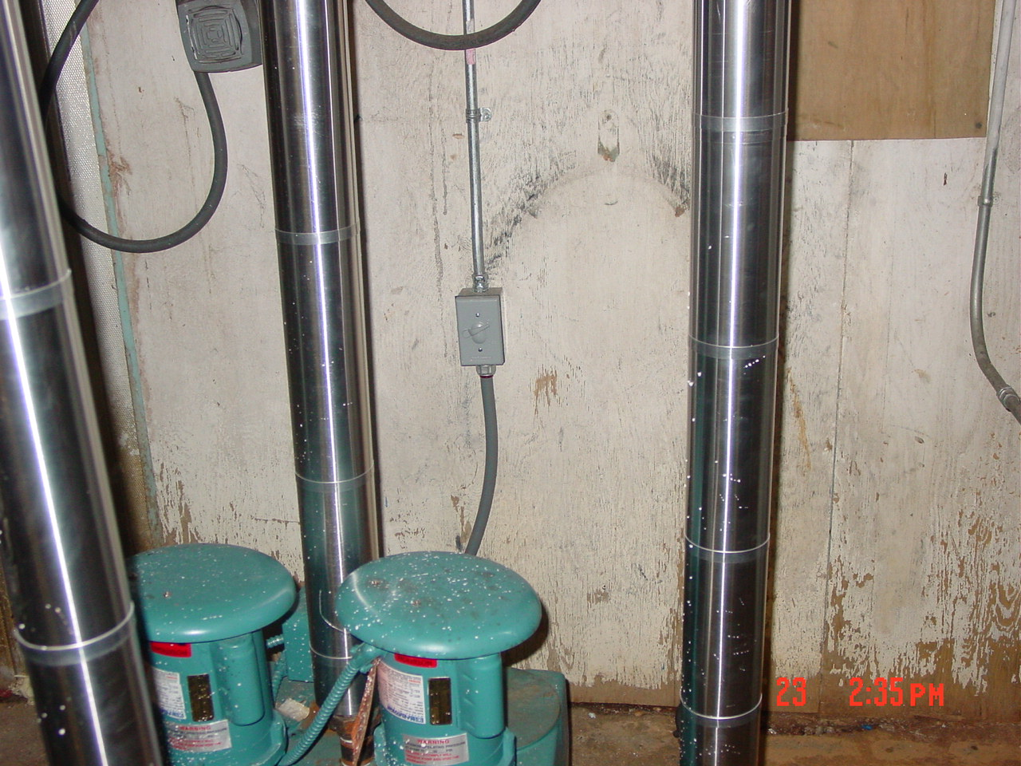
    - Allow the unit to heat up for 20 minutes.
    - Make sure the air is blowing at the back of the dryers.
    - Close the dryer air gates to force the air into the dryers.
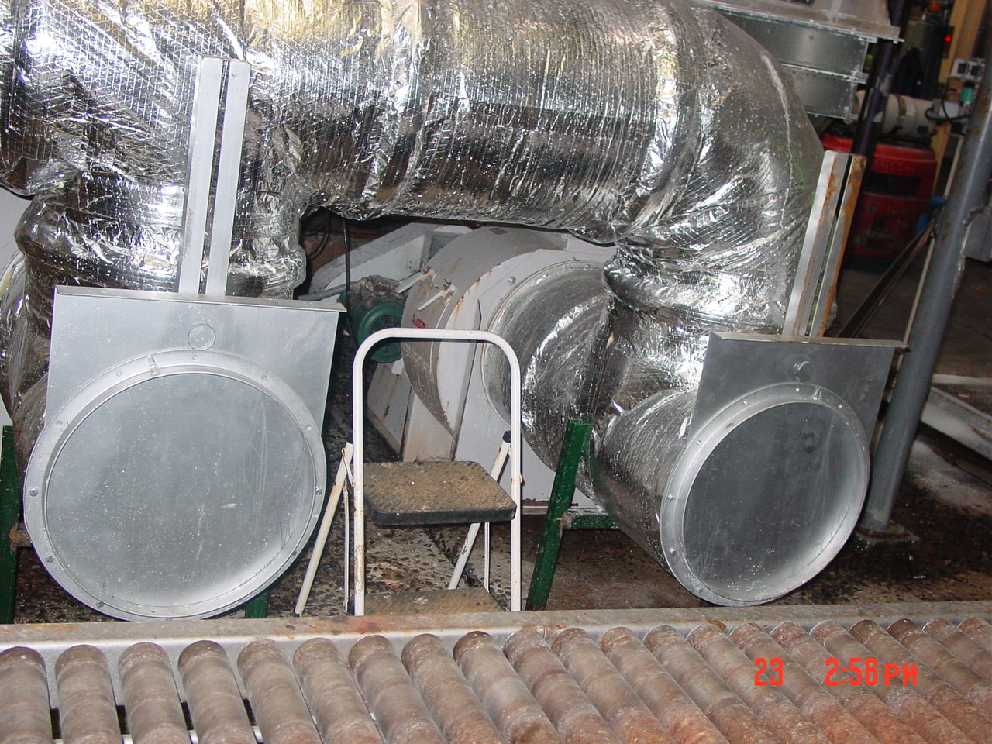

- Operating
    - When doing rounds, ensure the dehumidifier control panel screen says that the unit is “Running”

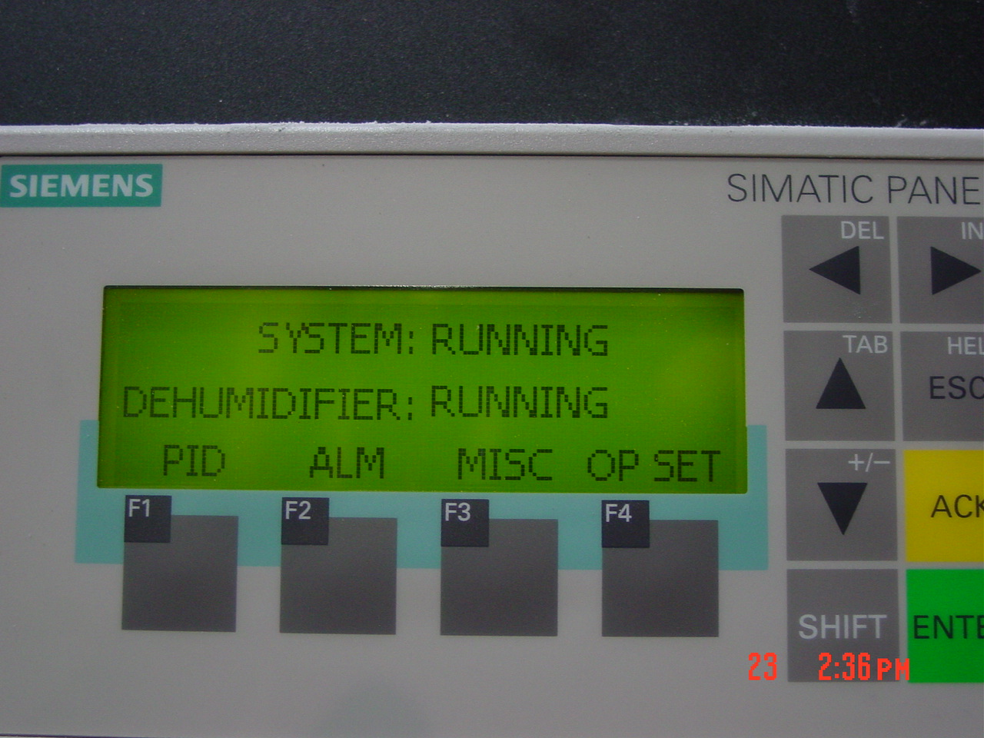

    - In the event that the moisture levels of the product are not in the control parameters make adjustments to the Salt Dryer/Cooler. Refer to SOP (Salt Dryer/Cooler Start up and Shutdown P12-PR-200-085) for instructions.
- Shut Down
    - Open the dryer air gates to allow room air into dryers

    - At the dehumidifier control panel, turn the switch from “Manual” to “Off”.

    - With gloves on, close the dehumidifier steam supply valve completely.

- Reference Documents

N/A

- Change Information

Document review- updated format using new template and numbering system.
Changed owner.

